Кравченко Сергей Григорьевич
Position applied for: Boatswain  Date of birth: 03.12.1968 (age: 48)  Citizenship: Ukraine  Residence permit in Ukraine: No  Country of residence: Ukraine  City of residence: Odessa  Permanent address: Ивановка Одесская обл Б,Деревянко 78 кв 12  E-Mail: sergey-k1968@mail.ru  U.S. visa: No  E.U. visa: No  Ukrainian biometric international passport: Not specified  Date available from: 01.08.2009  English knowledge: Poor  Minimum salary: 1500 $ per month | 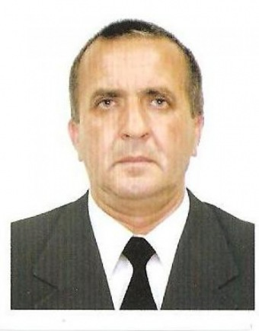

Experience:
Position | From / To | Vessel name | Vessel type | DWT | ME | BHP | Flag | Shipowner | Crewing
Able Seaman | 07.06.2006-22.11.2006 | IRENE | Universal Ship | 22100 |  | - | Bratislava |  | Sudoservis
Ordinary Seaman | 23.12.2005-07.06.2006 | IRENE | Universal Ship | 22100 |  | - | Bratnslava |  | Sudoservis
Able Seaman | 10.09.2004-20.09.2005 | LTBianco | Ro-Ro | 20000 |  | - | Италия |  | Норма
Able Seaman | 06.06.2003-14.05.2004 | ASSEDO | Passenger Ship |  |  | - | Украина |  | Украинское морское агенство
Ordinary Seaman | 25.12.2002-07.04.2003 | ASSEDO | Passenger Ship | 20000 |  | - | Украина |  | Украинское морское агенство

