Ilichev Edyard
Position applied for: Electrician  Date of birth: 09.06.1966 (age: 51)  Citizenship: Ukraine  Residence permit in Ukraine: No  Country of residence: Ukraine  City of residence: Bakhchisaray  Permanent address: s.Bahchisorai str.Frunze 93-27  Contact Tel. No: +38 (063) 572-71-39 / +38 (065) 545-27-62  E-Mail: edu8785@mail.ru  U.S. visa: No  E.U. visa: No  Ukrainian biometric international passport: Not specified  Date available from: 30.11.2013  English knowledge: Moderate  Minimum salary: 2000 $ per month | 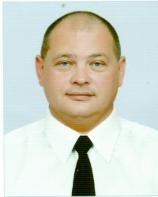

Experience:
Position | From / To | Vessel name | Vessel type | DWT | ME | BHP | Flag | Shipowner | Crewing
Electrician | 31.07.2010-31.01.2011 | ASABA 2 | Ro-Ro | 4876 | 2x2982 | 5x450 | Moroni | Maurico Shipping LTD-Seychelles | Rial Expres
Electrician | 31.05.2009-31.12.2009 | SALAMANDRA | Ro-Ro | 3542 | 2x2350 | 750 | Moroni | Intracoastal Trading Services S.A. | ChinaTailhou
Electrician | 10.06.2008-31.07.2008 | m/v Tolstov | Dry Cargo | 3994 | 1340 | 1200 | KNR | REGINA SHIPPING S.A. | Blek Si Servis

