Maliuk Roman
Position applied for: Chief Officer  Date of birth: 06.08.1982 (age: 35)  Citizenship: Ukraine  Residence permit in Ukraine: Yes  Country of residence: Ukraine  City of residence: Kherson  Permanent address: Komkova str.  Contact Tel. No: +38 (050) 917-42-11  E-Mail: maliuk22@mail.ru  U.S. visa: No  E.U. visa: No  Ukrainian biometric international passport: Not specified  Date available from: 24.07.2014  English knowledge: Good  Minimum salary: 6000 $ per month | 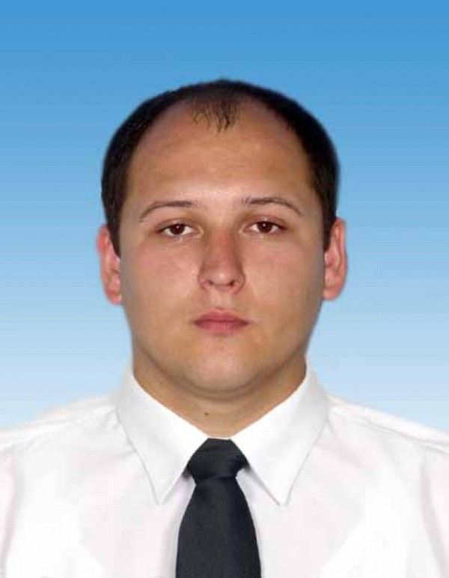

Experience:
Position | From / To | Vessel name | Vessel type | DWT | ME | BHP | Flag | Shipowner | Crewing
Chief Officer | 12.03.2013-08.07.2013 | BURGTOR | Multi-Purpose Vessel | 3500 | MAK | - | AntiguaBarbuda | Reederei Strahlmann | &mdash;
Chief Officer | 12.07.2012-20.11.2012 | HOLSTENTOR | Multi-Purpose Vessel | 3500 | MAK | - | AntiguaBarbuda | Reederei Strahlmann | &mdash;
Chief Officer | 21.12.2011-06.03.2012 | ARLAU | Multi-Purpose Vessel | 3700 | MAK | - | AntiguaBarbuda | Reederei Strahlmann | &mdash;
Chief Officer | 03.05.2011-30.08.2011 | ELBETOR | Multi-Purpose Vessel | 3500 | MAK | - | Antigua&Barbuda | Reederei Strahlmann | &mdash;
Chief Officer | 30.08.2010-06.01.2011 | ELBETOR | Multi-Purpose Vessel | 3500 | MAK | - | AntiguaBarbuda | Reederei Strahlmann | L-Streame

