Chystiakov Anton Valeriyvich
Position applied for: Able Seaman  Date of birth: 24.12.1984 (age: 32)  Citizenship: Ukraine  Residence permit in Ukraine: Yes  Country of residence: Ukraine  City of residence: Odessa  Permanent address: Lenina Str 20/16  Contact Tel. No: +38 (050) 279-09-21  E-Mail: antonukr@hotmail.com  Skype: anton0507836544  U.S. visa: No  E.U. visa: No  Ukrainian biometric international passport: Not specified  Date available from: 24.09.2017  English knowledge: Poor  Minimum salary: 1200 $ per month | 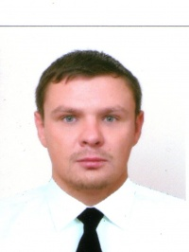

Experience:
Position | From / To | Vessel name | Vessel type | DWT | ME | BHP | Flag | Shipowner | Crewing
Able Seaman | 01.11.2016-29.04.2017 | Lucky Sunday | Bulk Carrier | 80032 | Flex | - | Panama | Skipper Marine Limited | ProfyChip

Documents and further information:
All documents in the collection, ready to work.

