Iatsenko Gennadii Viktorovich
Position applied for: Electrician  Date of birth: 08.09.1981 (age: 36)  Citizenship: Ukraine  Residence permit in Ukraine: No  Country of residence: Ukraine  City of residence: Odessa  Contact Tel. No: +38 (093) 845-93-95 / +38 (099) 475-97-60  E-Mail: genchik27rus@mail.ru  U.S. visa: No  E.U. visa: No  Ukrainian biometric international passport: Not specified  Date available from: 01.05.2014  English knowledge: Poor  Minimum salary: 1000 $ per month | 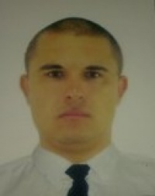

Experience:
Position | From / To | Vessel name | Vessel type | DWT | ME | BHP | Flag | Shipowner | Crewing
Electrician | 01.08.2012-01.10.2012 | Khadzhibey | Passenger Ship | 675 | SULZER NEW 6 AL 20/24 | 1140 | Ukraine | Soleks | &mdash;

