Serov Dmytro
Position applied for: Chief Officer  Date of birth: 18.04.1977 (age: 40)  Citizenship: Ukraine  Residence permit in Ukraine: No  Country of residence: Ukraine  City of residence: Mariupol  Permanent address: Lenina str.99-60  Contact Tel. No: +38 (099) 029-61-20  E-Mail: neos1@mail.ru  U.S. visa: No  E.U. visa: No  Ukrainian biometric international passport: Not specified  Date available from: 20.11.2013  English knowledge: Good  Minimum salary: 7200 $ per month | 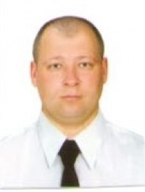

Experience:
Position | From / To | Vessel name | Vessel type | DWT | ME | BHP | Flag | Shipowner | Crewing
Chief Officer | 04.05.2013-30.09.2013 | Navios Etoile | Bulk Carrier | 179234 | B W | - | Panama | Ducale marine ltd | Epsilon
Chief Officer | 12.06.2012-05.02.2013 | Navios Star | Bulk Carrier | 76662 | BW | - | Panama | Star Maritime Enterprises | Elvictor
2nd Officer | 05.07.2011-13.03.2012 | Navios Star | Bulk Carrier | 76662 | B W | - | Panama | Star Maritime Enterprises | Elvictor

