Mykhaylenko Igor
Position applied for: 2nd Officer  Date of birth: 10.04.1989 (age: 28)  Citizenship: Ukraine  Residence permit in Ukraine: Yes  Country of residence: Ukraine  City of residence: Odessa  Contact Tel. No: +38 (093) 536-29-79 / +38 (095) 191-32-88  E-Mail: mixa.igor89@gmail.com  Skype: 1  U.S. visa: No  E.U. visa: No  Ukrainian biometric international passport: Not specified  Date available from: 10.11.2017  English knowledge: Moderate  Minimum salary: 1800 $ per month | 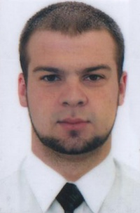

Experience:
Position | From / To | Vessel name | Vessel type | DWT | ME | BHP | Flag | Shipowner | Crewing
2nd Officer | 05.08.2014-13.01.2015 | Dovbas Voyager | General Cargo | 3134 |  | - | Moldova | Moon Shadov Marine Co. | Eurobulk
2nd Officer | 20.07.2013-16.03.2014 | Volgo Balt 242 | General Cargo | 3472 |  | 1030 | Moldova | Sae Logistic International LTD | Eurobulk
2nd Officer | 29.05.2013-02.07.2013 | Leo V | General Cargo | 5176 |  | 1326 | Moldova | Stella Polare | Eurobulk
2nd Officer | 21.03.2012-30.11.2012 | Dune | Dry Cargo | 2457 |  | 1030 | Togo | Helsman Shipping | &mdash;
2nd Officer | 08.11.2010-10.05.2011 | Dune | Dry Cargo | 2457 |  | 1030 | Malta | Helsman Shipping | &mdash;
2nd Officer | 20.02.2010-06.07.2010 | Dune | Dry Cargo | 2457 |  | 1030 | Malta | Helsman Shipping | &mdash;

Documents and further information:
completely new documents from 19.05.14

