Корж Антон Николаевич
Position applied for: 3rd Engineer  Date of birth: 08.04.1983 (age: 34)  Citizenship: Ukraine  Residence permit in Ukraine: No  Country of residence: Ukraine  City of residence: Sevastopol  Permanent address: ул.Б.Михайлова 19-11  Contact Tel. No: +38 (095) 362-63-18  E-Mail: Antonkorzh@inbox.ru  U.S. visa: No  E.U. visa: No  Ukrainian biometric international passport: Not specified  Date available from: 12.07.2009  English knowledge: Good  Minimum salary: 3500 $ per month | 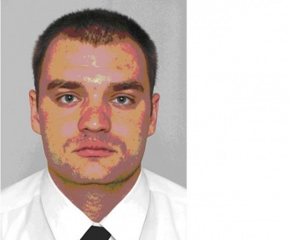

Experience:
Position | From / To | Vessel name | Vessel type | DWT | ME | BHP | Flag | Shipowner | Crewing
3rd Engineer | 29.11.2008-03.04.2009 | CEG Galaxy | Dry Cargo | 1035 | Caterpillar | 1020 | Antigua & Barbuda | Luddeke | &mdash;
3rd Engineer | 26.09.2007-20.04.2008 | White Mountain | Refrigerator | 6533 | mitsubishi | 8500 | panama | laskaridis shipping company | MTC
Motorman 1st class | 24.11.2006-02.07.2007 | Cold Wind | Refrigerator | 5323 | mitsubishi | 7000 | panama | Laskaridis shipping company | MTC
Motorman 1st class | 20.01.2006-10.11.2006 | pjk-432 | OSV - Offshore Supply Vessel | 179mt | russian diesel | 2450 | antigua &barbuda | Sevastopol shipping port | &mdash;

Documents and further information:
no valid for servise on tankers

