Yeshchyenko Eldar Reshatovych
Position applied for: Ordinary Seaman  Date of birth: 25.11.1987 (age: 29)  Citizenship: Russia  Residence permit in Ukraine: No  Country of residence: Ukraine  City of residence: Simferopol  Contact Tel. No: +7 (978) 090-37-12  E-Mail: yes.eldar@mail.ru  Skype: eldar.yeshchyenko  U.S. visa: No  E.U. visa: No  Ukrainian biometric international passport: Not specified  Date available from: 01.09.2017  English knowledge: Moderate  Minimum salary: 1000 $ per month | 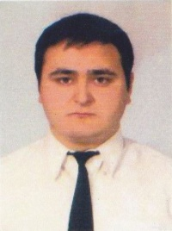

General details:
Document | Number | Place of issue | Date of expiry
Civil passport | 372842 | 900-003 | 00.00.0000

Experience:
Position | From / To | Vessel name | Vessel type | DWT | ME | BHP | Flag | Shipowner | Crewing
Deck Cadet | 10.03.2010-25.09.2010 | m/v "SANTIAGO" | Multi-Purpose Vessel | 3504 | MAN 7L 28/32 A-D, 1715 kW at 745 rpm | 1715 | Antigua and Barbuda | Briese Schiffahrts GmbH & Co. KG MS "PEW | OOO "Briese Swallow Sevastopol"
Deck Cadet | 06.03.2009-05.09.2009 | m/v "PETER" | Multi-Purpose Vessel | 5530 | MAN B&W, Diesel AG 6 L 40/54, 4320 kW | 5760 | Liberia | MS "PETER" Schiffahrts GmbH & Co. Reeder | OOO "Briese Swallow Sevastopol"

