Areshkin Vladyslav
Position applied for: 3rd Officer  Date of birth: 16.01.1992 (age: 25)  Citizenship: Ukraine  Residence permit in Ukraine: No  Country of residence: Ukraine  City of residence: Bilhorod-Dnistrovskyy  Permanent address: Malovskogo 10  Contact Tel. No: +38 (048) 750-63-22 / +38 (063) 322-11-81  E-Mail: vladjordan@mail.ru  U.S. visa: Yes. Expiration date 07.05.2018  E.U. visa: No  Ukrainian biometric international passport: Not specified  Date available from: 20.10.2014  English knowledge: Good  Minimum salary: 3000 $ per month | 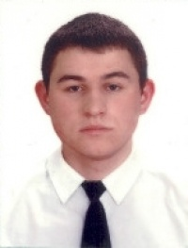

Experience:
Position | From / To | Vessel name | Vessel type | DWT | ME | BHP | Flag | Shipowner | Crewing
3rd Officer | 12.04.2014-26.09.2014 | CHEMTRANS RHINE | Oil Product Tanker | 35022 RT |  | 9085 | Liberia | Share Investments Inc. | Eurocrew
Deck Cadet | 21.05.2013-23.11.2013 | Chemtrans Riga | Oil Product Tanker | 34810 |  | 8020 | Liberian | CST | eurocrewing

Documents and further information:
All documents to 3rd officer position

