Скрипник Михаил Владимирович
Position applied for: Ordinary Seaman  Date of birth: 14.10.1975 (age: 42)  Citizenship: Ukraine  Residence permit in Ukraine: No  Country of residence: Ukraine  City of residence: Mariupol  Permanent address: Б-р Комсомольский, 24-57  Contact Tel. No: +38 (062) 923-72-18  E-Mail: michael_0275@mail.ru  U.S. visa: No  E.U. visa: No  Ukrainian biometric international passport: Not specified  Date available from: 30.07.2009  English knowledge: Excellent  Minimum salary: 1000 $ per month | 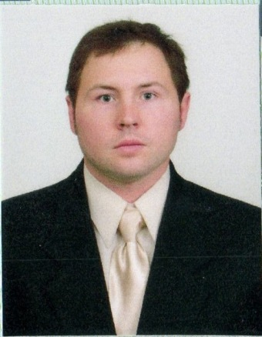

Experience:
Position | From / To | Vessel name | Vessel type | DWT | ME | BHP | Flag | Shipowner | Crewing
Steward | 12.09.2003-11.06.2004 | m/v “Cinzia D’Amato” | Bulk Carrier | 74 715 |  | - | Netherlands Ant. | Komrowski | Bark Marine Agency
Steward | 09.04.2002-24.01.2003 | m/v “Dorian” | Container Ship | 22150 |  | - | Liberia | Komrowski | Bark Marine Agency
Steward | 07.05.2001-18.12.2001 | m/v “CMA-CGM Karukera” | Container Ship | 23850 |  | - | Liberia | Komrowski | Bark Marine Agency

Documents and further information:
Certificate of competency 00290/2009/06 09.06.2009 Mariupol
Endorsement 00290/2009/06 09.06.2009 11.02.2014 Mariupol
Personal safety 116881-AS 11.02.2009 11.02.2014 Mariupoi
Prof. in survival craft 21012-AS 06.02.2009 06.02.2014 Mariupol
TANKER FAMILIRIZATION 20833 HC 05.05.2009 05.05.2014 Mariupol
Inter. P’port No: AM 729543 Issued: 11 jan 2001 Valid: 11 jan 2011 Place of issue: Mariupol
Seamans book No: AB 422752 Issued: 09 jun 2009 Valid: 09 jun 2014 Place of issue: Mariupol
Civil P’port No: KH 093369 Date of issue: 19 mar 1996 Place of issue: Poltava

