Davarashvyli Nodar
Position applied for: Master  Date of birth: 01.10.1971 (age: 46)  Citizenship: Ukraine  Residence permit in Ukraine: Yes  Country of residence: Ukraine  City of residence: Kherson  Contact Tel. No: +38 (099) 205-37-52  E-Mail: skynad2010@gmail.com  Skype: skynad2001  U.S. visa: No  E.U. visa: Yes. Expiration date 05.01.2019  Ukrainian biometric international passport: Not specified  Date available from: 22.08.2017  English knowledge: Good  Minimum salary: 8000 $ per month | 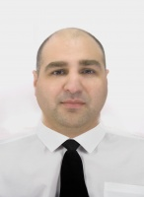

Experience:
Position | From / To | Vessel name | Vessel type | DWT | ME | BHP | Flag | Shipowner | Crewing
Master | 05.05.2016-04.10.2016 | Green Toledo | Refrigerator |  |  | - | Liberia | Green Management | &mdash;

