Solodovnikov Vitaliy
Position applied for: Master  Date of birth: 14.09.1981 (age: 36)  Citizenship: Ukraine  Residence permit in Ukraine: No  Country of residence: Ukraine  City of residence: Odessa  Contact Tel. No: +38 (048) 701-57-94 / +38 (096) 333-90-05  E-Mail: solodovnikov7@yandex.ru  Skype: vitalis726  U.S. visa: No  E.U. visa: No  Ukrainian biometric international passport: Not specified  Date available from: 01.08.2018  English knowledge: Good  Minimum salary: 9100 $ per month | 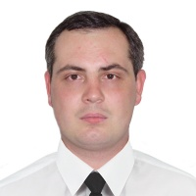

Experience:
Position | From / To | Vessel name | Vessel type | DWT | ME | BHP | Flag | Shipowner | Crewing
Master | 01.01.2017-20.04.2017 | Amelie | Bulk Carrier | 34680 |  | - | Liberia | Johann M.K. Blumenthal HmbG | &mdash;

