Peregybenko Oleksandr
Position applied for: Master  Date of birth: 22.05.1965 (age: 52)  Citizenship: Ukraine  Residence permit in Ukraine: Yes  Country of residence: Ukraine  City of residence: Kherson  Contact Tel. No: +38 (050) 568-26-69  E-Mail: alex2165@bk.ru  Skype: free_spirit29  U.S. visa: No  E.U. visa: No  Ukrainian biometric international passport: Not specified  Date available from: 31.05.2017  English knowledge: Moderate  Minimum salary: 3 $ per month | 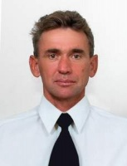

Documents and further information:
Good experience in sailing industry, charter, night watches(OOW), single handed watch keeping, rebuilding wooden and plastic yachts, repair different systems (mechanic, hydraulic, electric etc.), excellent tender driving skills and excellent carpentry skills, varnishing, polish and paint.

