APPLICATION FORM / PERSONAL DATA

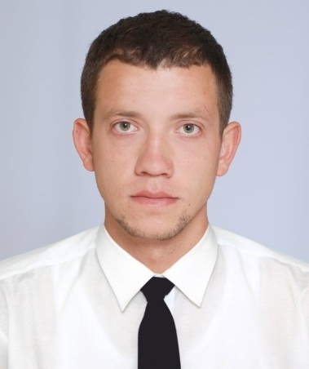 | Volchok Andrey  Position: Motorman/Engine cadet
 | GENERAL INFORMATION
 | Date of Birth: |  | 06.08.1989 |  | Mob. Phone: | +7(978) 767 24 14
 | Nationality: |  | Russian |  | E-mail: | andrey.volchok@gmail.com
 | City: |  | Sevastopol |  | English level: | Good
 |  |  |  |  | Work with mixed crew
DOCUMENTS |  | NUMBER |  | DATE/PLACE OF ISSUE |  | VALID UP
Seaman’s book |  | AB 543763 |  | 04.12.2014/Kherson |  | 04.12.2019
National passport |  | 7814 046289 |  | 13.04.2014/Sevastopol
International passport |  | 75 6802943 |  | 29.01.2018/Krasnodar |  | 29.01.2028
Certificate of proficiency |  | 11509/2014/07 |  | 07.11.2014/Nikolaev
Rank  Oil and chemical tanker |  | Second class motorman  01252/2017/11 20.03.2017/Kherson 07.02.2022
CERTIFICATES
Advanced Fire Fighting |  | 19720 |  | 10.12.2014/Illichivsk |  | 10.12.2019
Medical First aid |  | 11701 |  | 10.12.2014/Illichivsk |  | 10.12.2019
Proficiency in Survival craft |  | 23816 |  | 04.09.2014/Illichivsk |  | 04.09.2019
Security Awareness |  | 22154 |  | 04.09.2014/Illichivsk |  | 04.09.2019
Basic Safety Training |  | 22586 |  | 04.09.2014/Illichivsk |  | 04.09.2019
Seamen’s medical certificate |  | 29289 |  | 16.02.2018/Sevastopol |  | 16.02.2019
Yellow fever |  |  |  | 22.01.2015/Sevastopol |  | 22.01.2025

PREVIOUS SEA EXPERIENCE
Type of vessel | Name of vessel | DWT | Engine | Flag | Name of company | Rank | From/till
Reefer vessel | «Azov» | 1280 | 852 | UA | «Tranil» | Motorman | 03.06.2014
 |  |  |  |  |  |  | 05.08.2014
Reefer vessel | «Ieva Simonaityte» | 3372 | 2x2650 | LT | «Baltlanta» | Motorman | 05.06.2015
 |  |  |  |  |  |  | 24.11.2015
Reefer vessel | «Ieva Simonaityte» | 3372 | 2x2650 | LT | «Baltlanta» | Motorman | 26.01.2016
 |  |  |  |  |  |  | 05.04.2016
Reefer vessel | «Ieva Simonaityte» | 3372 | 2x2650 | LT | «Baltlanta» | Motorman | 07.06.2016
 |  |  |  |  |  |  | 15.08.2016
Reefer vessel | «Ieva Simonaityte» | 3372 | 2x2650 | LT | «Baltlanta» | Motorman | 03.11.2016
 |  |  |  |  |  |  | 18.01.2017
Reefer vessel | «Ieva Simonaityte» | 3372 | 2x2650 | LT | «Baltlanta» | Motorman | 05.06.2017
 |  |  |  |  |  |  | 07.11.2017

ADDITIONAL INFORMATION
Height: 192 | Weight: 92 |  | Hair: dark | Eyes: green | Shoes size: 45 | Overall size: 54-56
Civil Status: |  | Single
Computer proficiency: |  | Excellent

