Samoylenko Mikhail
Position applied for: 2nd Officer  Date of birth: 06.10.1985 (age: 32)  Citizenship: Russia  Residence permit in Ukraine: Yes  Country of residence: Russia  City of residence: Saint Petersburg  Permanent address: 1/1 Izborskaya Str  Contact Tel. No: +7 (911) 860-04-65  E-Mail: Maykal85@mail.ru  Skype: Maykal.Samoylenko  U.S. visa: No  E.U. visa: No  Ukrainian biometric international passport: Not specified  Date available from: 24.02.2017  English knowledge: Good  Minimum salary: 2600 $ per month | 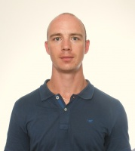

Experience:
Position | From / To | Vessel name | Vessel type | DWT | ME | BHP | Flag | Shipowner | Crewing
2nd Officer | 23.01.2016-24.06.2016 | Estesun | Bulk Carrier | 21500 | B&W | 3900 | PANAMA | Boden Shipping | Worldinter

