Bazhev Petro
Position applied for: Master  Date of birth: 02.12.1974 (age: 42)  Citizenship: Ukraine  Residence permit in Ukraine: Yes  Country of residence: Ukraine  City of residence: Odessa  Contact Tel. No: +38 (067) 480-50-51  E-Mail: peter.bazhev@Gmail.com  Skype: +38 (067) 480 5051 - Viber & WhatsApp  U.S. visa: Yes. Expiration date 13.06.2018  E.U. visa: Yes. Expiration date 30.09.2018  Ukrainian biometric international passport: Not specified  Date available from: 01.10.2017  English knowledge: Excellent  Minimum salary: 8500 $ per month | 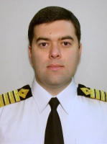

Documents and further information:
All documents as per STCW requirements are on hand.
I am working as Master since 2005.
Multi-crew experience: Sweden, Germany, UK, Croatia, Poland, Ukraine, Russia, Greek, Philippines.
English level Ã¢â¬â Fluently.
My CV could be sent upon your request.

