Starov Mykola Vladimirovich
Position applied for: Electrical Engineer  Date of birth: 24.08.1984 (age: 33)  Citizenship: Ukraine  Residence permit in Ukraine: Yes  Country of residence: Ukraine  City of residence: Odessa  Contact Tel. No: +38 (050) 776-08-98 / +38 (055) 233-15-27  E-Mail: mykola-starov@ukr.net  U.S. visa: No  E.U. visa: No  Ukrainian biometric international passport: Not specified  Date available from: 31.08.2014  English knowledge: Good  Minimum salary: 5000 $ per month | 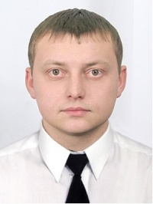

Experience:
Position | From / To | Vessel name | Vessel type | DWT | ME | BHP | Flag | Shipowner | Crewing
 | 27.10.2013-17.04.2014 | Queen of luck | Container Ship | 23130 | MAN | 13125 | Panama | Princess of Luck Shipping LTD | Victoriaoceanway
 | 14.10.2012-15.05.2013 | John I | Bulk Carrier | 43000 | Hyundai - B&W | 10300 | Panama | q-shipping | nyki
 | 08.02.2012-26.07.2012 | TES-1(ARTA) | Oil Product Tanker | 8840 | MAK | 4000 | Moldova | corporation "TES" | Peloris
 | 11.07.2011-14.01.2012 | Smat | Ro-Ro | 6698 | Volvo penta | 3500 | Malta | Terminal Yug | Albion-neo
 | 10.08.2010-26.04.2011 | Feruz | Ro-Ro | 6628 | Volvo penta | 3500 | Malta | Terminal Yug | Albion-neo

