Мастепанов Игорь
Position applied for: 2nd Engineer  Date of birth: 21.06.1966 (age: 51)  Citizenship: Ukraine  Residence permit in Ukraine: No  Country of residence: Ukraine  City of residence: Sevastopol  Contact Tel. No: +38 (069) 257-45-87 / +38 (095) 425-14-40  E-Mail: mastepanovigor@mail.ru  U.S. visa: No  E.U. visa: No  Ukrainian biometric international passport: Not specified  Date available from: 05.06.2009  English knowledge: Moderate  Minimum salary: 2700 $ per month | 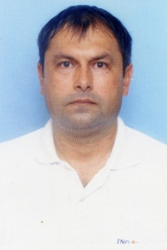

Experience:
Position | From / To | Vessel name | Vessel type | DWT | ME | BHP | Flag | Shipowner | Crewing
3rd Officer | 16.02.2008-27.09.2008 | PANAGIA-1 | Bulk Carrier | 28567 |  | - | MALTA | Fisher Maritime(Flanmare Shipping) | Tiara
3rd Officer | 21.05.2007-25.09.2007 | ATHINA | Bulk Carrier | 34173 |  | - | St.Vincent&Grenadine | Adriatik S.A. | TIARA
2nd Officer | 26.12.2006-04.05.2007 | Vyacheslav Shishcov | Dry Cargo | 1768 |  | - | Cambodia | North Intertrade | Tiara
Able Seaman | 05.08.2005-10.01.2006 | Madonna | Shuttle Tanker | 38214 |  | - | LIBERIA | Project.Ship.Ink | Tranzit Expres

Documents and further information:
Документы в наличии ;медицинская комиссия готова

