Мезенцев Игорь Валерьевич
Position applied for: 2nd Engineer  Date of birth: 05.08.1969 (age: 48)  Citizenship: Ukraine  Residence permit in Ukraine: No  Country of residence: Ukraine  City of residence: Sevastopol  Permanent address: ул.Меньшикова 84-111  Contact Tel. No: +38 (050) 904-41-88  E-Mail: mez@mail.ru  U.S. visa: No  E.U. visa: No  Ukrainian biometric international passport: Not specified  Date available from: 10.06.2009  English knowledge: Excellent  Minimum salary: 9000 $ per month | 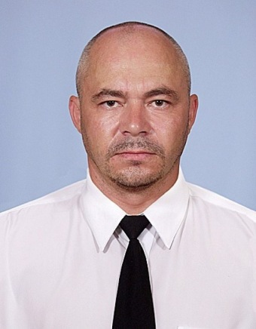

Experience:
Position | From / To | Vessel name | Vessel type | DWT | ME | BHP | Flag | Shipowner | Crewing
2nd Engineer | 03.10.2008-01.03.2009 | Wilhelm Schulte | Gas Tanker | 18045 |  | 12552 | UK | BSM | SPMG г.Одесса
2nd Engineer | 21.11.2007-05.06.2008 | Ievoli red | OSV - Offshore Supply Vessel | 969 |  | 2x2266 | Italy | Marnavi navigation | Интермарин,г.Керчь
3rd Engineer | 11.12.2006-02.08.2007 | Batu | Bulk Carrier | 42648 |  | 9500 | Либерия | Ahrenkiel group | &mdash;
3rd Engineer | 10.12.2005-04.06.2006 | Shetland | Gas Tanker | 14102 |  | 13100 | UK | Zodiac | O-link,г.Одесса

