Moloshnyi Eduard
Position applied for: Wiper  Date of birth: 09.07.1992 (age: 25)  Citizenship: Ukraine  Residence permit in Ukraine: No  Country of residence: Ukraine  City of residence: Odessa  Contact Tel. No: +38 (048) 249-19-37 / +38 (096) 409-10-70  E-Mail: eduard.moloshnyj@mail.ru  U.S. visa: No  E.U. visa: No  Ukrainian biometric international passport: Not specified  Date available from: 18.01.2013  English knowledge: Moderate  Minimum salary: 800 $ per month | 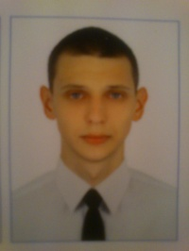

Experience:
Position | From / To | Vessel name | Vessel type | DWT | ME | BHP | Flag | Shipowner | Crewing
Motorman 2nd class | 16.10.2011-11.03.2012 | Canopus | General Cargo | 6223 | SKL 8NVDS48 3-V | 2*1320 HP | Saint-Vincent & Gren | MEDITERRANEAN SAILING SKIFF INC. | Vernal

Documents and further information:
Seaman’s passport
Travel passport
CoC and Endorsement to the CoC - 3rd engineer ; 2 class motorman
Certificate - Basic Safety Training/ Proficiency In Survival Craft/ Advanced Fire Fighting/ Medical First Aid/ Dangerous And Hazardous Substances
Education - Maritime college of technical fleet ONMA / Engineering department 2007-2011

