Biryukov Oleg Igorovich
Position applied for: Ordinary Seaman  Date of birth: 04.12.1991 (age: 25)  Citizenship: Ukraine  Residence permit in Ukraine: No  Country of residence: Ukraine  City of residence: Kherson  Permanent address: Patona 3 kv 6  Contact Tel. No: +38 (050) 151-91-64 / +38 (055) 227-76-02  E-Mail: oleg.biryukov.91@mail.ru  U.S. visa: No  E.U. visa: No  Ukrainian biometric international passport: Not specified  Date available from: 27.01.2013  English knowledge: Moderate  Minimum salary: 800 $ per month | 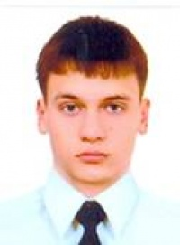

Experience:
Position | From / To | Vessel name | Vessel type | DWT | ME | BHP | Flag | Shipowner | Crewing
Ordinary Seaman | 03.12.0010-15.02.0012 | m/v Altrany | Dry Cargo | 9000 |  | /3356 | Valetta | Belstar Shipping Co LTD | Travelclub 44Ltd
Ordinary Seaman | 10.12.2010-10.03.0011 | m/v Credo | Dry Cargo | 3000 |  | SKL/1500 | Malta | Dial Shipping | &mdash;

