Korshunov Andrii
Position applied for: Ordinary Seaman  Date of birth: 23.08.1970 (age: 47)  Citizenship: Ukraine  Residence permit in Ukraine: No  Country of residence: Ukraine  City of residence: Sevastopol  Contact Tel. No: +38 (069) 240-47-69 / +38 (095) 151-92-47  E-Mail: andrii.korshunov.1970@mail.ru  U.S. visa: No  E.U. visa: No  Ukrainian biometric international passport: Not specified  Date available from: 31.12.2013  English knowledge: Moderate  Minimum salary: 500 $ per month | 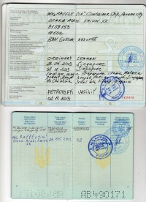

Experience:
Position | From / To | Vessel name | Vessel type | DWT | ME | BHP | Flag | Shipowner | Crewing
Ordinary Seaman | 23.05.2013-02.11.2013 | Rafflesia | Container Ship | 24548 |  | - | Panama | osaka asahi kaiun kk | marineman
Ordinary Seaman | 01.09.1988-01.12.1988 | antey | Tug Boat | 262 | 1470 | - | USSR | MorStroy | &mdash;
Wiper | 07.04.1988-31.08.1988 | antey | Tug Boat | 262 | 1470 | - | USSR | MorStroy | &mdash;

Documents and further information:
I know 1000 english words.

