Zenchenko Serhii Valentinovich
Position applied for: 3rd Officer  Date of birth: 06.07.1992 (age: 25)  Citizenship: Ukraine  Residence permit in Ukraine: Yes  Country of residence: Ukraine  City of residence: Izmail  Permanent address: nekarsova str.59  Contact Tel. No: +38 (048) 416-35-96 / +38 (067) 199-55-61  E-Mail: zen4ik2009@mail.ru  Skype: zenya888  U.S. visa: No  E.U. visa: No  Ukrainian biometric international passport: Not specified  Date available from: 10.11.2016  English knowledge: Good  Minimum salary: 2700 $ per month | 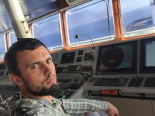

Experience:
Position | From / To | Vessel name | Vessel type | DWT | ME | BHP | Flag | Shipowner | Crewing
3rd Officer | 07.09.2015-15.04.2016 | Niledutch Rotterdam | Container Ship | 48039t | MAN BW | 26700 HP | Netherlands | Niledutch B.V. | Anglo Eastern group

