Кадема Петр Григорьевич
Position applied for: Master  Date of birth: 14.08.1968 (age: 49)  Citizenship: Ukraine  Residence permit in Ukraine: No  Country of residence: Ukraine  City of residence: Voznesensk  Contact Tel. No: +38 (067) 515-14-04  E-Mail: kadema1968@mail.ru  U.S. visa: No  E.U. visa: No  Ukrainian biometric international passport: Not specified  Date available from: 17.08.2009  English knowledge: Good  Minimum salary: 7500 $ per month | 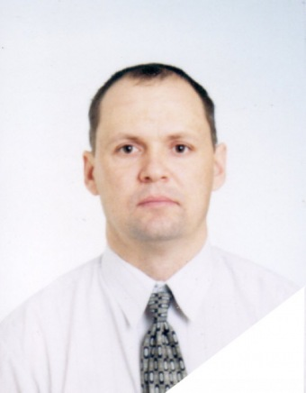

Experience:
Position | From / To | Vessel name | Vessel type | DWT | ME | BHP | Flag | Shipowner | Crewing
Master | 16.10.2008-26.02.2009 | Hyundai Future | Container Ship | 24799 |  | - | Panama | Speed carrier Corp. | Danaos
Master | 04.12.2007-09.04.2008 | Faina | Ro-Ro | 9019 |  | - | Belize | Redrick Company | Tomex
Master | 18.04.2007-13.08.2007 | Faina | Ro-Ro | 9019 |  | - | Belize | Redrick Copmpany | Lumar

