Odainic Alexandr Anatol
Position applied for: Deck Cadet  Date of birth: 20.07.1989 (age: 28)  Citizenship: Moldova  Residence permit in Ukraine: No  Country of residence: Moldova  Permanent address: Tineretului-2, r.Causeni  Contact Tel. No: +373 (243) 712-41 / +373 (784) 771-03  E-Mail: sanwelo@mail.ru  U.S. visa: No  E.U. visa: No  Ukrainian biometric international passport: Not specified  Date available from: 25.09.2012  English knowledge: Moderate  Minimum salary: 50-100 $ per month | 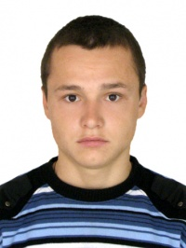

Documents and further information:
Inter. Pâport No: A 3042692 Issued: 18.06.2007 Valid: 18.06.2017 Place of issue: MDA Causeni
Seaman\\\&#39s book No: AB 401533 Issued:17.05.2009 Valid: 17.05.2014 Place of issue: Odessa
Name of Maritime Institution attended Address of institution From To Degree of Diploma
Odessa National Maritime Academy Didrihsona13, Odessa, Ukraine 2007 2012 Bachelor in maritime and river transport
STCW Certificates Number Issued Valid Place of issue
Certificate of competency
Endorsement
Personal safety 1161/2008 09.04.2008 09.04.2013 Odessa
Advanced fire fighting 0816/2009 10.03.2009 10.03.2014 Odessa
Prof. in survival craft 1074/2009 04.03.2009 04.03.2014 Odessa
Medical first aid 0202/2009 10.03.2009 10.03.2014 Odessa
Medical care
Hazardous cargoes
Tanker familiarization 0608/2009 27.10.2009 27.10.2014 Odessa

