Tymoshchuk
Position applied for: Cook  Date of birth: 25.01.1966 (age: 51)  Citizenship: Ukraine  Residence permit in Ukraine: Yes  Country of residence: Ukraine  City of residence: Odessa  Permanent address: Korabelnaya 7 /10  Contact Tel. No: +38 (063) 576-96-45  E-Mail: oleg_timson2007@ukr.net  U.S. visa: No  E.U. visa: No  Ukrainian biometric international passport: Yes  Date available from: 02.02.2016  English knowledge: Good  Minimum salary: 2000 $ per month | 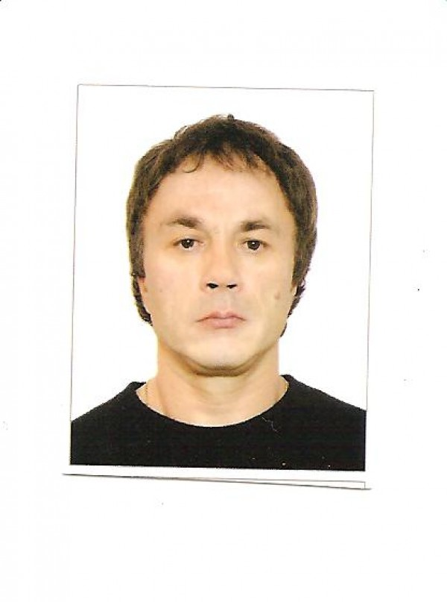

Experience:
Position | From / To | Vessel name | Vessel type | DWT | ME | BHP | Flag | Shipowner | Crewing
Cook | 22.08.2007-13.10.2007 | PAGENTURN | Anchor Handling Tug Supply |  |  | - | VILLA | TIDEWATER | SEACOVER
Cook | 16.02.2007-29.05.2007 | GOLDBLAT | Anchor Handling Tug Supply |  |  | - | BELIZE | TIDEWATER | SEACOVER
Cook | 29.06.2006-12.12.2006 | UPPLAND | Container Ship |  |  | - | ANTIGUA | SCOTT SHIPP | NAUTILUS
Cook | 12.12.2005-23.04.2006 | ZIM VENEZUELA | Container Ship |  |  | - | GIBRALTA | MUKLEBUSTHAUG. | NAUTILUS
Cook | 20.01.2005-31.05.2005 | M/V RIO NEGRO | Container Ship |  |  | - | LIBER | NMS NAUTIK | ALYFA NARIN
Cook | 22.03.2003-23.10.2003 | WEHR FLOTTBEK | Container Ship |  |  | - | LIBER | OSKAR WEHR | STAFFCENTR
Cook | 30.04.2002-10.10.2002 | M/V ELQVI | Container Ship |  |  | - | MARSHAL | OSKAR WEHR | STAFFCENTR
Cook | 09.08.2001-19.02.2002 | M/V QVETZAL | Container Ship |  |  | - | German | OSKAR WEHR | STAFFCENTR
Cook | 10.01.2008-08.07.0008 | IEVEI GLREEN | Anchor Handling Tug Supply |  |  | - | ITALY | MARNAVI | INTER MARIN
Cook | 27.02.2004-04.07.0004 | WEHR HAVEL | Container Ship |  |  | - | MARSHAL | OSKAR WEHR | STAFFCENTR

Documents and further information:
CONT Fortuna 2 MALiTA TSCHUDI ch/cook 29.10.08-03.03.09 TOTUS

