Nedialkov Vadim Anatolyevich
Position applied for: Ordinary Seaman  Date of birth: 15.10.1984 (age: 33)  Citizenship: Ukraine  Residence permit in Ukraine: Yes  Country of residence: Ukraine  City of residence: Odessa  Contact Tel. No: +38 (097) 928-44-16  E-Mail: nedyalkov.v84@gmail.com  Skype: Nedyalkov.v84@gmail.com  U.S. visa: No  E.U. visa: No  Ukrainian biometric international passport: Not specified  Date available from: 18.09.2017  English knowledge: Moderate  Minimum salary: 800 $ per month | 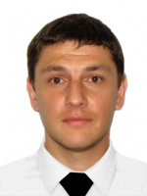

Experience:
Position | From / To | Vessel name | Vessel type | DWT | ME | BHP | Flag | Shipowner | Crewing
Ordinary Seaman | 15.03.2016-20.04.2016 | Mv.Sirena | Cruise Ship |  |  | - |  |  | &mdash;

