Strunin Denys Alexandrovich
Position applied for: Motorman 2nd class  Date of birth: 06.07.1978 (age: 39)  Citizenship: Ukraine  Residence permit in Ukraine: No  Country of residence: Ukraine  City of residence: Sevastopol  Permanent address: óë. Ë. Òîëñòîãî 4 êâ.5  Contact Tel. No: +38 (050) 604-21-58 / +38 (069) 255-96-90  E-Mail: dsd626@mail.ru  U.S. visa: No  E.U. visa: No  Ukrainian biometric international passport: Not specified  Date available from: 01.05.2013  English knowledge: Poor  Minimum salary: 1000 $ per month | 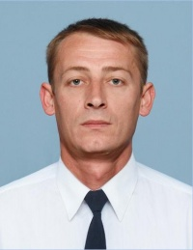

Experience:
Position | From / To | Vessel name | Vessel type | DWT | ME | BHP | Flag | Shipowner | Crewing
Motorman 2nd class | 08.08.2012-22.10.2012 | Atlantic Orion |  | 3500 | 5295kWt | - | Belize city | Atlantic Orion Shipping LTD | Marine Agency Titarenko

