Gusyev Maksym Vitalievich
Position applied for: Ordinary Seaman  Date of birth: 16.11.1978 (age: 39)  Citizenship: Ukraine  Residence permit in Ukraine: No  Country of residence: Ukraine  City of residence: Sevastopol  Permanent address: 48, Generala Zhidilova, apt.47  Contact Tel. No: +38 (066) 225-39-71 / +38 (069) 248-44-92  E-Mail: mmmaxi@mail.ru  U.S. visa: No  E.U. visa: No  Ukrainian biometric international passport: Not specified  Date available from: 26.10.2013  English knowledge: Good  Minimum salary: 2500 $ per month | 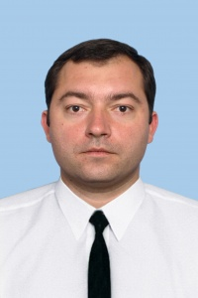

Experience:
Position | From / To | Vessel name | Vessel type | DWT | ME | BHP | Flag | Shipowner | Crewing
Ordinary Seaman | 19.04.2011-18.12.2011 | Sifnos | Bulk Carrier | 32956 |  | - | Liberia | Golde Port | Golden Port Odessa
Ordinary Seaman | 08.09.2010-09.11.2010 | KIL-158 | Research vessel | 4750 |  | - | Russia | Russian navi | &mdash;

