Stoyanov Petro
Position applied for: Electrical Engineer  Date of birth: 04.09.1962 (age: 55)  Citizenship: Ukraine  Residence permit in Ukraine: Yes  Country of residence: Ukraine  City of residence: Odessa  Permanent address: Bocharova str.71  Contact Tel. No: +38 (048) 718-48-30 / +38 (066) 927-61-96  E-Mail: ann.stoyanova2011@yandex.ua  U.S. visa: No  E.U. visa: No  Ukrainian biometric international passport: Not specified  Date available from: 12.01.2015  English knowledge: Moderate  Minimum salary: 4800 $ per month | 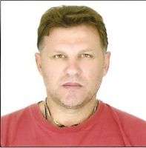

General details:
Document | Number | Place of issue | Date of expiry
Civil passport | KK042452 | Odessa | 00.00.0000
Seamanâs passport | 475016 | Odessa | 30.01.2014
Tourist passport | 01903/2004/08 | odessa | 00.00.0000

Certificates:
Type | Number | Place of issue | Date of expiry
El.Eng. | 01903/2004/08 | odessa | 00.00.0000
El.Eng. | 01903/2004/08 | odessa | 11.10.2015

Experience:
Position | From / To | Vessel name | Vessel type | DWT | ME | BHP | Flag | Shipowner | Crewing
 | 04.04.2014-17.08.2014 | Achilleus | Bulk Carrier | 55000 | MAN B+w | 10500 | Malta | PORTLINE | EQUNOX

