Мамкин Александр Владимирович
Position applied for: Motorman 1st class  Date of birth: 28.08.1975 (age: 42)  Citizenship: Ukraine  Residence permit in Ukraine: No  Country of residence: Ukraine  City of residence: Mariupol  Permanent address: ул.Таганрогская, д.247, кв.5  Contact Tel. No: +38 (067) 604-90-91  E-Mail: inemikina@ukr.net  U.S. visa: No  E.U. visa: No  Ukrainian biometric international passport: Not specified  Date available from: 20.06.2009  English knowledge: Not specified  Minimum salary: 1500 $ per month | 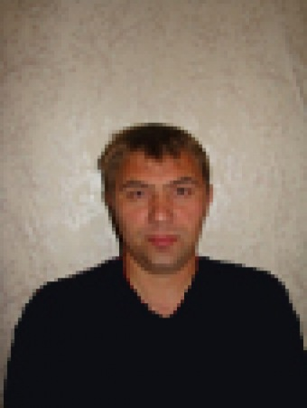

Experience:
Position | From / To | Vessel name | Vessel type | DWT | ME | BHP | Flag | Shipowner | Crewing
Motorman 1st class | 25.09.2008-24.03.2009 | Med Glory | General Cargo | 9500 | Mitsubishi | 6500 | Cambodia | Melfarco Ltd | Global Consalting
Motorman 1st class | 16.12.2007-27.06.2008 | Med Glory | General Cargo | 9500 | Mitsubishi | 6500 | Cambodia | Melfarco Ltd | Global Consalting
Motorman 1st class | 02.02.2004-02.04.2004 | Николай Иванченко | Tug Boat | 250 |  | 2х600 | Украина | Азовский Морской Порт | &mdash;

Documents and further information:
CERTIFICATES:
Description Number Place Issue Expiry
Certificate of Competency (Qualified Motorman) 00342/2007/06 Mariupol 17.10.2007
Endorsement (Qualified Motorman) 00342/2007/06 Mariupol 17.10.2007 24.07.2012
Certificate of Competency (Ship’s turner) 00221/2007/06 Mariupol 30.10.2007
Endorsement (Ship’s turner) 00221/2007/06 Mariupol 30.10.2007 24.07.2012
Seaman’s Book AB384651 Mariupol 02.10.2007 02.10.2012
Travel Passport EA088679 Mariupol 01.08.2007 01.08.2017
Basic Safety Training Evidence 10204-AS Mariupol 24.07.2007 24.07.2012
Ship’s turner Sertificate 130014 Mariupol 16.10.2007
Breathing Apparatus 10204-BS Mariupol 24.07.2007

