Sergii Yevtodii
Position applied for: Ordinary Seaman  Date of birth: 17.01.1983 (age: 34)  Citizenship: Ukraine  Residence permit in Ukraine: No  Country of residence: Ukraine  City of residence: Odessa  Contact Tel. No: +38 (097) 906-20-75  E-Mail: moe_logovo@mail.ru  U.S. visa: No  E.U. visa: No  Ukrainian biometric international passport: Not specified  Date available from: 20.10.2013  English knowledge: Good  Minimum salary: 1100 $ per month | 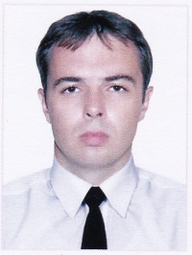

Experience:
Position | From / To | Vessel name | Vessel type | DWT | ME | BHP | Flag | Shipowner | Crewing
Ordinary Seaman | 06.12.2012-14.06.2013 | Ioanna D | Bulk Carrier | 35000 |  | - |  |  | &mdash;
Ordinary Seaman | 27.05.2012-11.10.2012 | MSC Scotland | Container Ship | 47120 |  | - |  |  | &mdash;
Mess Boy | 07.02.2012-27.05.2012 | MSC Scotland | Container Ship | 47120 |  | - |  |  | &mdash;
Mess Boy | 03.06.2011-28.12.2011 | Grand Vision | Container Ship | 44013 |  | - |  |  | &mdash;

