Khrushch Iurii
Position applied for: Chief Officer  Date of birth: 25.05.1977 (age: 40)  Citizenship: Ukraine  Residence permit in Ukraine: No  Country of residence: Ukraine  City of residence: Kyiv  Contact Tel. No: +38 (067) 774-94-09 / +38 (093) 571-00-15  E-Mail: yuriy_1977@ukr.net  U.S. visa: No  E.U. visa: No  Ukrainian biometric international passport: Not specified  Date available from: 07.10.2013  English knowledge: Good  Minimum salary: 5000 $ per month | 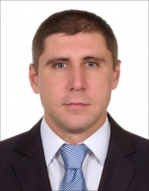

Experience:
Position | From / To | Vessel name | Vessel type | DWT | ME | BHP | Flag | Shipowner | Crewing
Chief Officer | 17.03.2013-21.06.2013 | AURORA | Multi-Purpose Vessel | 5780 | MAK | 2700 kWt | CURACAO | TRANSHIP MANAGEMENT BV | ASKOLDAS
Chief Officer | 25.06.2012-27.12.2012 | AMALIA | Multi-Purpose Vessel | 5780 | MAK | 2700 kWt | CURACAO | TRANSHIP MANAGEMENT BV | ASKOLDAS

