Моторкин Михаил Владимирович
Position applied for: Able Seaman  Date of birth: 27.11.1975 (age: 41)  Citizenship: Ukraine  Residence permit in Ukraine: No  Country of residence: Ukraine  City of residence: Odessa  Permanent address: g.vishnevskogo  Contact Tel. No: +38 (097) 514-64-32  E-Mail: michaelmotorkin@mail.ru  U.S. visa: No  E.U. visa: No  Ukrainian biometric international passport: Not specified  Date available from: 18.07.2009  English knowledge: Excellent  Minimum salary: 2500 $ per month | 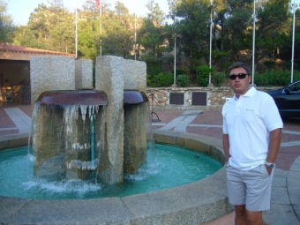

Experience:
Position | From / To | Vessel name | Vessel type | DWT | ME | BHP | Flag | Shipowner | Crewing
Waiter | 00.00.0000-11.12.2000 | Reagal impress | Passenger Ship |  |  | - | usa |  | global marine
Waiter | 00.00.0000-00.00.0000 | Apollon | Passenger Ship |  |  | - | greece |  | travag ltd
Waiter | 00.00.0000-00.00.0000 | Island Sun | Passenger Ship |  |  | - |  |  | skay ltd
Waiter | 00.00.0000-00.00.0000 | Island skay | Passenger Ship |  |  | - |  |  | admiral.prospekt
Waiter | 00.00.0000-00.00.0000 | orient qwian | Passenger Ship |  |  | - |  |  | volans

Documents and further information:
all dokyments available

