Bondarenko Vitaliy Ivanovich
Position applied for: Electrical Engineer  Date of birth: 04.04.1950 (age: 67)  Citizenship: Ukraine  Residence permit in Ukraine: Yes  Country of residence: Ukraine  City of residence: Odessa  Contact Tel. No: +38 (048) 711-85-08 / +38 (098) 731-66-17  E-Mail: bondarenko_inna@inbox.ru  Skype: bondarenko3661  U.S. visa: No  E.U. visa: No  Ukrainian biometric international passport: Not specified  Date available from: 01.12.2016  English knowledge: Moderate  Minimum salary: 3000 $ per month | 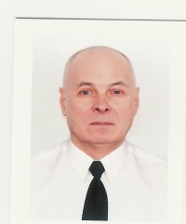

Experience:
Position | From / To | Vessel name | Vessel type | DWT | ME | BHP | Flag | Shipowner | Crewing
 | 24.10.2015-25.03.2016 | Avlemon | Bulk Carrier | 42584 | MAN.B.W 5S50MC | 5725 | Liberia |  | Arktus-Odessa LTD

