Krsovsky Oleksndr
Position applied for: Motorman 2nd class  Date of birth: 21.02.1984 (age: 33)  Citizenship: Ukraine  Residence permit in Ukraine: No  Country of residence: Ukraine  City of residence: Vylkove  Permanent address: ODESSA REGION  Contact Tel. No: +38 (095) 685-04-58 / +38 (097) 644-16-81  E-Mail: danila.com.ua@ukr.net  U.S. visa: No  E.U. visa: No  Ukrainian biometric international passport: Not specified  Date available from: 21.09.2012  English knowledge: Good  Minimum salary: 700 $ per month | 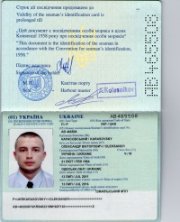

Experience:
Position | From / To | Vessel name | Vessel type | DWT | ME | BHP | Flag | Shipowner | Crewing
Motorman 2nd class | 21.07.2013-05.11.2013 | Sea star | General Cargo | 5300 | WUXI | 2300 | Union of Comoros | Merchant marine shipping Ltd | Ukrtramp
Motorman 2nd class | 15.02.2012-19.08.2012 | Volgo-Balt 205 | Dry Cargo | 3000 | Scoda | 1030 | Cambodia | Nadedezhda Marine Ltd | Azimut

