Sliusarenko Oleksandr
Position applied for: Chief Officer  Date of birth: 19.10.1966 (age: 51)  Citizenship: Ukraine  Residence permit in Ukraine: Yes  Country of residence: Ukraine  City of residence: Odessa  Contact Tel. No: +38 (048) 765-06-94 / +38 (067) 291-45-15  E-Mail: ut5fb@ukr.net  U.S. visa: No  E.U. visa: No  Ukrainian biometric international passport: Not specified  Date available from: 01.12.2014  English knowledge: Good  Minimum salary: 7500 $ per month | 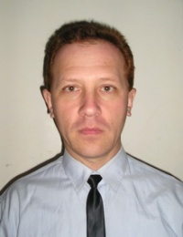

Experience:
Position | From / To | Vessel name | Vessel type | DWT | ME | BHP | Flag | Shipowner | Crewing
Chief Officer | 22.01.2014-23.06.2014 | SILVER SURFER | Bulk Carrier | 180000 |  | - | Marshall Islands | ADK | Niki
Chief Officer | 25.04.2013-02.08.2013 | Veenus | Bulk Carrier | 79100 |  | - | Liberia | Wallem | Ukraine
Chief Officer | 14.04.2012-16.07.2012 | Matisse | Bulk Carrier | 35000 |  | - | Marshall Islands | Portunato | Alfa Navigation
Chief Officer | 06.02.2012-13.04.2012 | Happy Success | Bulk Carrier | 42000 |  | - | Panama | Portunato | Alfa Navigation
Chief Officer | 17.06.2011-19.11.2011 | Matisse | Bulk Carrier | 35000 |  | - | Marshall Islands | Portunato | SP Management
Chief Officer | 24.08.2010-18.11.2010 | Genco Raptor | Bulk Carrier | 76499 |  | - | Marshall Islands | Anglo Eastern | Singh Marine

