Baranetskyy Roman
Position applied for: Chief Officer  Date of birth: 05.12.1975 (age: 41)  Citizenship: Ukraine  Residence permit in Ukraine: No  Country of residence: Ukraine  City of residence: Kerch  Contact Tel. No: +372 (5930) 6911 / +38 (050) 876-94-66  E-Mail: rtd2007@bk.ru  U.S. visa: No  E.U. visa: No  Ukrainian biometric international passport: Not specified  Date available from: 07.12.2013  English knowledge: Good  Minimum salary: negotiate per month | 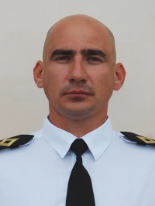

Experience:
Position | From / To | Vessel name | Vessel type | DWT | ME | BHP | Flag | Shipowner | Crewing
Chief Officer | 31.08.2013-03.11.2013 | Merkur Cloud | Container Ship | 22026 |  | - | Liberia | F.A. Vinnen | Uniteam
Chief Officer | 28.10.2012-28.03.2013 | Merkur Cloud | Container Ship | 22026 |  | - | Liberia | F.A. Vinnen | Uniteam
Chief Officer | 01.10.2011-24.02.2012 | Tete Rickmers | Container Ship | 18006 |  | - | Marshall Islands | Tete Rickmers | Uniteam
Chief Officer | 16.09.2010-24.03.2011 | Somers Isles | Container Ship | 7642 |  | - | Netherlands | JR Shipping | Marlow Nawigation
Chief Officer | 12.12.2009-24.04.2010 | Endeavor | Container Ship | 7642 |  | - | Netherlands | JR Shipping | Marlow Nawigation
Chief Officer | 01.06.2009-02.08.2009 | Endurance | Container Ship | 7642 |  | - | Netherlands | JR Shipping | Marlow Nawigation

Documents and further information:
+Dutch documents+Marshall Islands documents

