Shatyrov Maksym Valeriyovich
Position applied for: Fitter-Welder  Date of birth: 15.05.1987 (age: 30)  Residence permit in Ukraine: No  Country of residence: Ukraine  City of residence: Izmail  Permanent address: 77, Lomonosova str  Contact Tel. No: +38 (067) 117-16-63  E-Mail: maksym150587@rambler.ru  U.S. visa: No  E.U. visa: No  Ukrainian biometric international passport: Not specified  Date available from: 21.05.2013  English knowledge: Moderate  Minimum salary: 1500 $ per month | 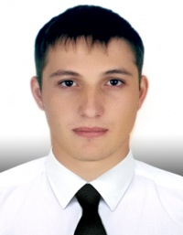

Experience:
Position | From / To | Vessel name | Vessel type | DWT | ME | BHP | Flag | Shipowner | Crewing
Motorman 2nd class | 05.12.2011-14.03.2012 | Kapitan Shyriagin | General Cargo | 3839 | SKL | 1700 | Comoros | East Shipping Limited | &mdash;
Motorman 2nd class | 09.07.2010-09.12.2010 | Volgo-Balt 115 | General Cargo | 3450 | Shkoda | 1030 | Cambodia | East Shipping Limited | &mdash;
Welder | 22.07.2012-00.00.0000 | Odessit | General Cargo | 3450 | Shkoda | 1030 | Giurgiulesti | Sea traffic shipping ca | &mdash;

Documents and further information:
3-Ð³Ð¾Ð´Ð° ÑÐ²Ð°ÑÑÐ¸ÐºÐ¾Ð¼ 4-ÑÐ¾Ð³Ð¾ ÑÐ°Ð·ÑÑÐ´Ð° Ð½Ð° ÑÑÐ´Ð¾ÑÐµÐ¼Ð¾Ð½ÑÐ½Ð¾Ð¼ Ð·Ð°Ð²Ð¾Ð´Ðµ.01.01.2007 / 25.06.2010

