Kabakhmatenko Arkadii
Position applied for: Motorman-Electrician  Date of birth: 02.08.1988 (age: 29)  Citizenship: Ukraine  Residence permit in Ukraine: No  Country of residence: Ukraine  City of residence: Odessa  Contact Tel. No: +38 (048) 582-55-55 / +38 (097) 275-91-91  E-Mail: kabahmatenko@yandex.ru  U.S. visa: No  E.U. visa: No  Ukrainian biometric international passport: Not specified  Date available from: 23.12.2014  English knowledge: Poor  Minimum salary: 900 $ per month | 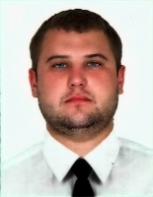

Experience:
Position | From / To | Vessel name | Vessel type | DWT | ME | BHP | Flag | Shipowner | Crewing
Engine Cadet | 21.09.2012-21.11.2012 | Khadzhibey | Passenger Ship | 83 | 2x6AL 20/24 | 1140 | Ukraine | Soles | OMTC

