Чепурной Владимир Викторович
Position applied for: Ordinary Seaman  Date of birth: 25.10.1978 (age: 39)  Citizenship: Ukraine  Residence permit in Ukraine: No  Country of residence: Ukraine  City of residence: Kherson  Contact Tel. No: +38 (066) 512-51-18  E-Mail: vova_78@ukr.net  U.S. visa: No  E.U. visa: No  Ukrainian biometric international passport: Not specified  Date available from: 20.05.2010  English knowledge: Moderate  Minimum salary: 700 $ per month | 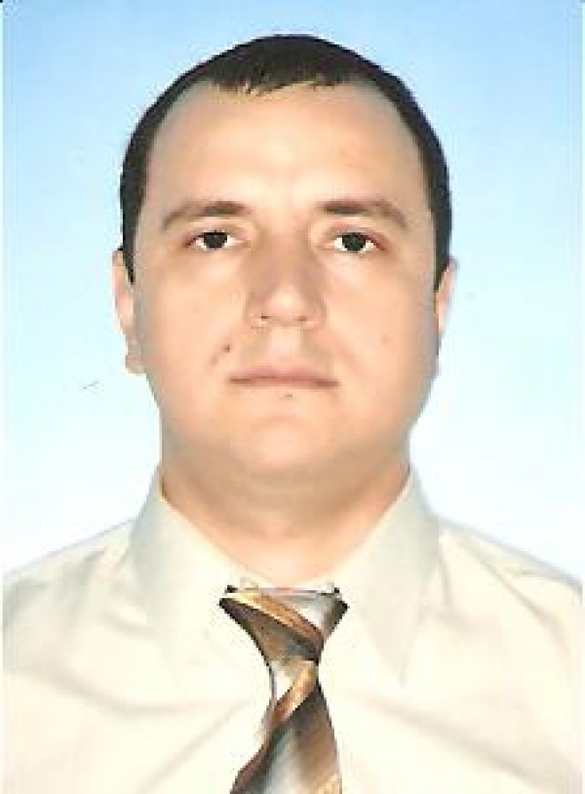

Experience:
Position | From / To | Vessel name | Vessel type | DWT | ME | BHP | Flag | Shipowner | Crewing
Ordinary Seaman | 02.02.2010-30.04.2010 | бт 1026 | Tug Boat |  |  | - | ua | delta service | &mdash;

