Burtsev Yuriy
Position applied for: Welder  Date of birth: 22.06.1965 (age: 52)  Citizenship: &mdash;  Residence permit in Ukraine: No  Country of residence: Ukraine  City of residence: Sevastopol  Contact Tel. No: +38 (069) 272-79-04 / +38 (099) 497-04-02  E-Mail: Yurij.burtzew@yandex.ru  U.S. visa: No  E.U. visa: No  Ukrainian biometric international passport: Not specified  Date available from: 01.11.2012  English knowledge: Poor  Minimum salary: 4000 $ per month | 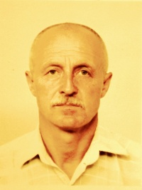

Experience:
Position | From / To | Vessel name | Vessel type | DWT | ME | BHP | Flag | Shipowner | Crewing
Welder | 05.06.2014-06.06.2014 | Mekhanik Kovtun |  |  |  | - | RUSSIA |  | &mdash;
Welder | 25.04.2014-17.05.2014 | Maironis |  |  |  | - |  |  | &mdash;
Welder | 27.03.2014-25.04.2014 | Balandis |  |  |  | - |  |  | &mdash;
Welder | 15.02.2014-27.03.2014 | Aleksandr Kosarev |  |  |  | - |  |  | &mdash;
Welder | 10.01.2014-11.02.2014 | Admiral Starikov |  |  |  | - |  |  | &mdash;
Able Seaman | 15.02.2013-04.09.2013 | Frio Ionian | Refrigerator |  |  | - | MONRJVIA | Astra inco rporated | &mdash;
Welder | 25.01.2012-00.00.0000 | MORE SODRUJESTV |  |  |  | - |  |  | &mdash;
Welder | 06.12.2013-00.00.0000 | Admiral Shabalin |  |  |  | - |  |  | &mdash;

Documents and further information:
WELDER APPROVAL TEST CERTIFICATE

