Олешков Александр
Position applied for: Able Seaman  Date of birth: 22.05.1976 (age: 41)  Citizenship: Ukraine  Residence permit in Ukraine: No  Country of residence: Ukraine  City of residence: Kerch  Permanent address: 24, G.Petrova str., apt.58  Contact Tel. No: +38 (066) 907-92-52  E-Mail: oleksandr1work@yahoo.com  U.S. visa: No  E.U. visa: No  Ukrainian biometric international passport: Not specified  Date available from: 19.07.2009  English knowledge: Poor  Minimum salary: 500 $ per month | 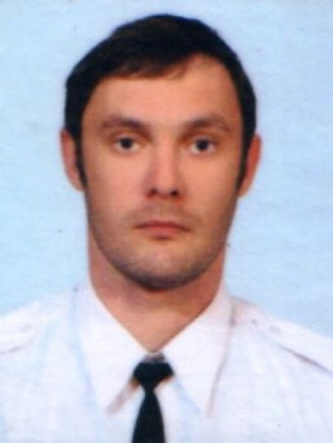

Experience:
Position | From / To | Vessel name | Vessel type | DWT | ME | BHP | Flag | Shipowner | Crewing
Able Seaman | 15.11.2006-27.12.2007 | Centaur | Tug Boat |  |  | - | Ukraine | ГАО Черноморнефтегаз | &mdash;

Documents and further information:
Qualified seaman certificate # 00032/2009/05 issued on 18.05.2009 (not valid for service in tankers)
Endorsement Qualified seaman certificate # 00032/2009/05 issued on 18.05.2009 until 05.02.2014
Basic Safety Training and Instruction # 06950/2009/25/01issued on 05.02.2009 expiry 05.02.2014
Proficiency in Survival Craft and Rescue Boats # 06967/2009/25/02 issued on 05.02.2009 expiry 05.02.2014
Carriage of Dangerous and Hazardous Substances #20409/MPS
Seamans ID Card # AB376949 issue 20.05.2009 expiry 20.05.2014 Kerch
Travel Passport # EK226583 issue 29.05.2009 expiry 29.05.2019 Kerch
Yellow fever vaccination issue 01.06.2009
Medical examination issue 22.05.2009 Kerch

