Artyomov Vadim
Position applied for: 3rd Officer  Date of birth: 11.11.1990 (age: 27)  Citizenship: Ukraine  Residence permit in Ukraine: No  Country of residence: Ukraine  City of residence: Izmail  Permanent address: vil. Broska, Stepova str, 11  Contact Tel. No: +38 (093) 764-67-33 / +38 (096) 368-43-89  E-Mail: vadim-artyomov@rambler.ru  U.S. visa: No  E.U. visa: No  Ukrainian biometric international passport: Not specified  Date available from: 29.11.2013  English knowledge: Good  Minimum salary: 1200 $ per month | 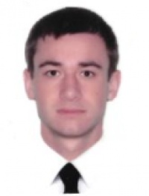

Experience:
Position | From / To | Vessel name | Vessel type | DWT | ME | BHP | Flag | Shipowner | Crewing
Ordinary Seaman | 20.12.2012-22.06.2013 | Elqui | Container Ship | 22878 | Sulzer | 1358 | Marshall Island | Oskar Wehr | Staff Centre
Deck Cadet | 27.01.2012-23.08.2012 | Wehr Elbe | Container Ship | 33750 | MAN BW | 2020 | Marshall Island | Oskar Wehr | Staff Centre
Deck Cadet | 10.08.2009-19.01.2010 | HS Berlioz | Container Ship | 34985 | MAN BW | 3313 | Liberia | Hansa Shipping | Lais

Documents and further information:
All documents are ready for position of 3rd Officer and OS

