Kucmenda Victor
Position applied for: Motorman-Oiler  Additional position applied for: Motorman 1st class  Date of birth: 24.02.1993 (age: 24)  Citizenship: Ukraine  Residence permit in Ukraine: Yes  Country of residence: Ukraine  City of residence: Odessa  Contact Tel. No: +38 (068) 653-96-28  E-Mail: vitek10219931@gmail.com  Skype: vitek10212  U.S. visa: No  E.U. visa: No  Ukrainian biometric international passport: Not specified  Date available from: 02.08.2017  English knowledge: Excellent  Minimum salary: 500 $ per month | 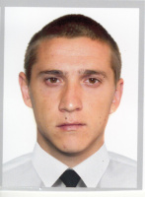

Experience:
Position | From / To | Vessel name | Vessel type | DWT | ME | BHP | Flag | Shipowner | Crewing
Motorman 1st class | 01.03.2016-08.02.2017 | Sandra | General Cargo | 3000 | SKL | 1134 | Matadi | Edison Prodject Lp | &mdash;

Documents and further information:
.

