Ivanov Vitaliy Robertovich
Position applied for: 3rd Officer  Date of birth: 25.06.1967 (age: 50)  Citizenship: Ukraine  Residence permit in Ukraine: Yes  Country of residence: Ukraine  City of residence: Odessa  Permanent address: str.Dnepropetrovskay doroga  Contact Tel. No: +38 (067) 937-26-20  E-Mail: ivanov.vr9@gmail.com  Skype: nil  U.S. visa: No  E.U. visa: No  Ukrainian biometric international passport: Not specified  Date available from: 08.06.2017  English knowledge: Moderate  Minimum salary: 2000 $ per month | 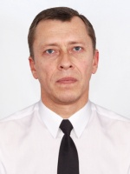

Experience:
Position | From / To | Vessel name | Vessel type | DWT | ME | BHP | Flag | Shipowner | Crewing
3rd Officer | 09.01.2014-07.03.2014 | Tanais Liader | Bulk Carrier | 27400 | B&W | 10200 | Belize | ROSSHIPCOM | S 4 Point

