Gurkaliuk Dmytro
Position applied for: Electric Cadet  Date of birth: 07.04.1993 (age: 24)  Citizenship: Ukraine  Residence permit in Ukraine: No  Country of residence: Ukraine  City of residence: Kherson  Contact Tel. No: +38 (047) 553-37-31 / +38 (050) 737-59-23  E-Mail: gurkaliuk@bk.ru  U.S. visa: No  E.U. visa: No  Ukrainian biometric international passport: Not specified  Date available from: 05.01.2014  English knowledge: Moderate  Minimum salary: 200 $ per month | 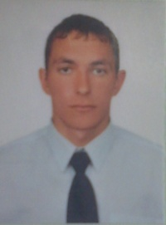

Experience:
Position | From / To | Vessel name | Vessel type | DWT | ME | BHP | Flag | Shipowner | Crewing
Electric Cadet | 01.10.2012-02.02.2013 | Danapris 2 | General Cargo | 3183 | SKL | 2x700 HP (515KW | UKRAINE | Capital Shipping Company | &mdash;

Documents and further information:
Medical first aid Ã¢ââ8159/13KH;
Advanced fire fighting Ã¢ââ9963/13KH;
Basic safety training Ã¢ââ19499/11KHl;
Proficiency in survival craft Ã¢ââ15402/12KH;
Certificate of competencyÃ¢ââ01362/2013/11 Third-class electrical engineer.

