Galdin Volodymyr
Position applied for: Master  Date of birth: 20.06.1961 (age: 56)  Citizenship: Ukraine  Residence permit in Ukraine: Yes  Country of residence: Ukraine  City of residence: Odessa  Permanent address: app.126, 19, Ilfa i Petrova str.  Contact Tel. No: +38 (067) 485-49-38  E-Mail: davidlee@ukr.net  Skype: Capt,Galdin.Vladimir  U.S. visa: Yes. Expiration date 10.04.2021  E.U. visa: No  Ukrainian biometric international passport: Not specified  Date available from: 01.12.2016  English knowledge: Excellent  Minimum salary: 9600 $ per month | 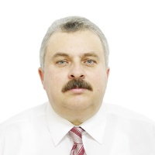

Experience:
Position | From / To | Vessel name | Vessel type | DWT | ME | BHP | Flag | Shipowner | Crewing
Master | 07.05.2016-21.08.2016 | Seaspan Hamburg | Container Ship | 50790 | MAN B&W | 37000 | Hong Kong | Seaspan, Canada | Univis
Master | 19.02.2016-17.04.2016 | NileDutch Rotterdam | Container Ship | 46000 | MAN B&W ME | 27000 | The Netherlands | NileDutch | AESM
Master | 29.06.2015-28.10.2015 | NileDutch Rotterdam | Container Ship | 46000 | MAN B&W ME | 2700 | The Netherlands | Niledutch | AESM

