Клименко Сергей Витальевич
Position applied for: Able Seaman  Date of birth: 28.11.1989 (age: 27)  Citizenship: Ukraine  Residence permit in Ukraine: No  Country of residence: Ukraine  City of residence: Odessa  Contact Tel. No: +38 (093) 449-26-84  E-Mail: Liga2010@mail.ru  U.S. visa: No  E.U. visa: No  Ukrainian biometric international passport: Not specified  Date available from: 28.02.2010  English knowledge: Moderate  Minimum salary: 1000 $ per month | 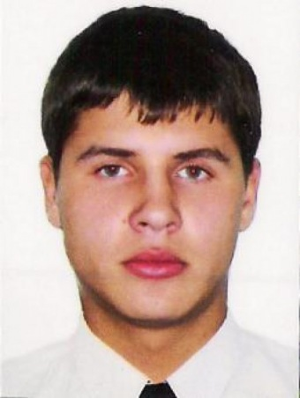

Experience:
Position | From / To | Vessel name | Vessel type | DWT | ME | BHP | Flag | Shipowner | Crewing
Ordinary Seaman | 17.06.2008-21.12.2008 |  | Shuttle Tanker | 58000 |  | - | Malta |  | &mdash;

Documents and further information:
Travel passport
. Seamans book
. Navigator diplom
. GMDSS Certificate
. Basic Safety Training
. Proficiency in Survival Craft
. Advanced Fire Fighting
. Medical First Aid
. Radar Navigation
. Dangerous & Hazardous Cargoes
. Ships Security Officer
. Tanker Familiarization

